**Black Box Testing (All cases)**

For black box testing we tested the app with ‘Android Studio Emulator’ with Nexus 5 device with Android 5.0 OS running to get appropriate results.

Furthermore we used monkeyrunner.bat plugin for *Android Studio* for black box testing and CPU-Z app for Performance Analysis.

The following is the Black box testing cases for the app developed:-

|  |  |  |  |  |
| --- | --- | --- | --- | --- |
| **S.No** | **Module** | **Experiment** | **Response** | **Pass/Fail** |
| 1 | Facebook activity | Facebook Button click/Navigation Menu button click | Facebook Fragment replaces main activity screen. | Pass |
| 2 | Instagram activity | Instagram Button click/Navigation Menu click | Instagram Fragment replaces main activity screen. | Pass |
| 3 | Twitter activity | Twitter Button click/Navigation Menu click | Twitter Fragment replaces main activity screen. | Pass |
| 4 | Snapchat activity | Snapchat Button click/Navigation Menu click | Snapchat Fragment replaces main activity screen. | Pass |
| 5 | Miscellaneous activity | Miscellaneous Button click/Navigation Menu click | Miscellaneous Fragment replaces main activity screen. | Pass |
| 6 | About Us activity | About us menu button pressed | About us Fragment replaces main activity screen | Pass |
| ˆ7 | Contact Us activity | Entering an invalid email | Response not accepted | Pass |
| 8 | Contact Us activity | Entering an email but no details | Response not accepted | Pass |
| 9 | Contact Us activity | Submitting a response without internet connection detected | No Internet connection detected response | Pass |
| 10 | Startup | Closing app before completely loaded | App closes | Pass |

**Performance Analysis(using *CPU-Z* app)**

CPU-Z is an app to calculate Ram usage and load on the software

For our application in the following screenshots, we tested the usage stats for the application:-

1. This first stat highlights the RAM usage:

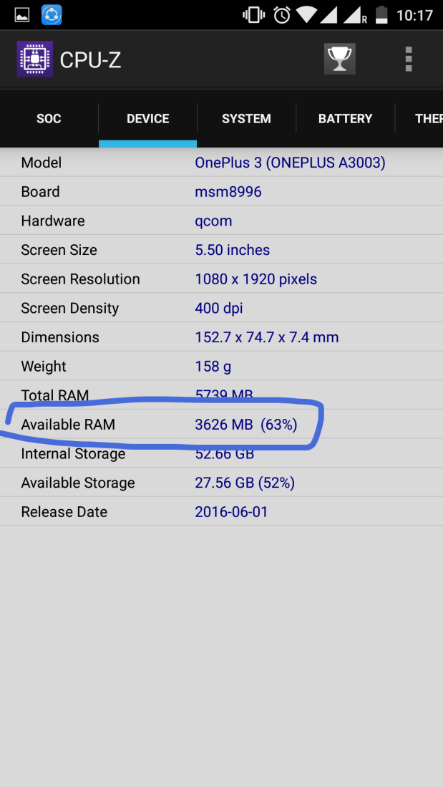 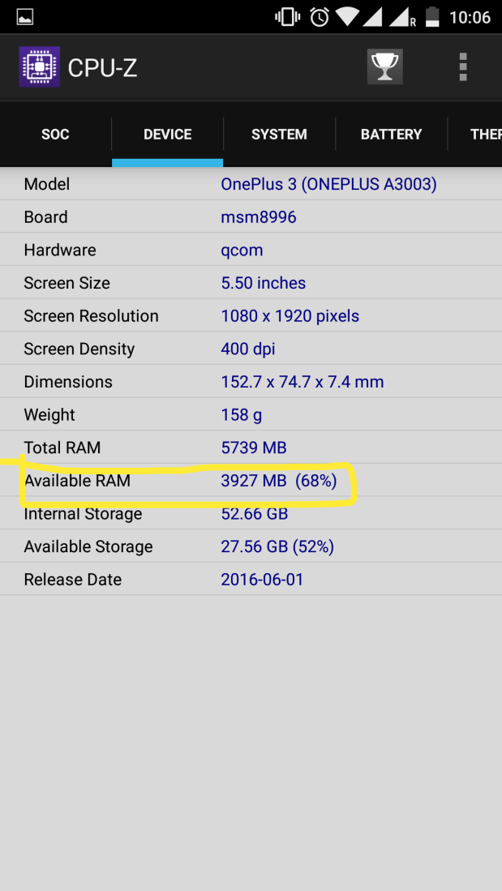

Comparing these, there is approximately **300MB Ram** usage from the app.

1. The second Stat comparison, checks for the CPU load by the application:

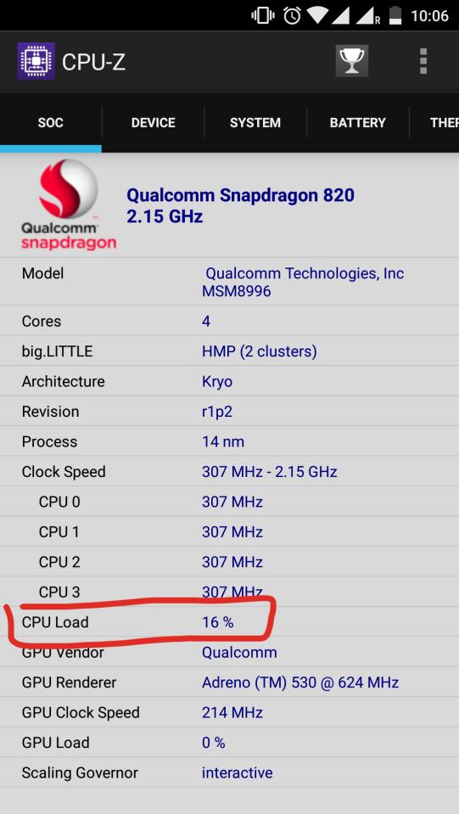

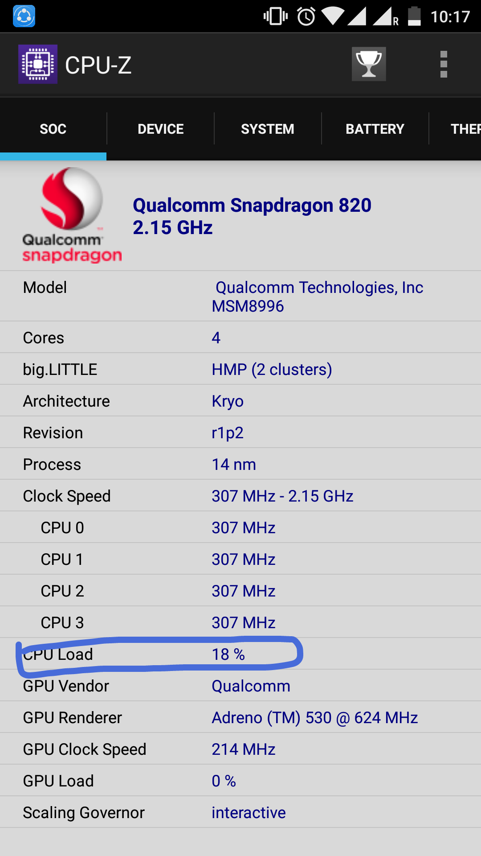

Comparing these, there is only **2% CPU load** on using the application, which makes it efficient.